Congo, Dem. Rep.

## Population Data

The data set shows the political stability estimate of the country each year.

## # A tibble: 23 x 5  
## country iso3c date population popCategory5  
## <chr> <chr> <dbl> <dbl> <chr>   
## 1 Congo, Dem. Rep. COD 1996 42757243 medium   
## 2 Congo, Dem. Rep. COD 1997 43827180 medium   
## 3 Congo, Dem. Rep. COD 1998 44849967 medium   
## 4 Congo, Dem. Rep. COD 1999 45919613 medium   
## 5 Congo, Dem. Rep. COD 2000 47105826 medium   
## 6 Congo, Dem. Rep. COD 2001 48428545 medium   
## 7 Congo, Dem. Rep. COD 2002 49871666 medium   
## 8 Congo, Dem. Rep. COD 2003 51425580 medium   
## 9 Congo, Dem. Rep. COD 2004 53068880 medium   
## 10 Congo, Dem. Rep. COD 2005 54785903 medium   
## 11 Congo, Dem. Rep. COD 2006 56578037 medium   
## 12 Congo, Dem. Rep. COD 2007 58453683 medium   
## 13 Congo, Dem. Rep. COD 2008 60411195 medium   
## 14 Congo, Dem. Rep. COD 2009 62448574 medium   
## 15 Congo, Dem. Rep. COD 2010 64563854 medium   
## 16 Congo, Dem. Rep. COD 2011 66755153 medium   
## 17 Congo, Dem. Rep. COD 2012 69020747 medium   
## 18 Congo, Dem. Rep. COD 2013 71358807 medium   
## 19 Congo, Dem. Rep. COD 2014 73767447 medium   
## 20 Congo, Dem. Rep. COD 2015 76244544 large   
## 21 Congo, Dem. Rep. COD 2016 78789127 large   
## 22 Congo, Dem. Rep. COD 2017 81398764 large   
## 23 Congo, Dem. Rep. COD 2018 84068091 large

# Population growth data

## # A tibble: 23 x 5  
## country iso3c date popGrowth popGrowthCat5   
## <chr> <chr> <dbl> <dbl> <chr>   
## 1 Congo, Dem. Rep. COD 1996 2.80 high growth rate   
## 2 Congo, Dem. Rep. COD 1997 2.47 moderate growth rate  
## 3 Congo, Dem. Rep. COD 1998 2.31 moderate growth rate  
## 4 Congo, Dem. Rep. COD 1999 2.36 moderate growth rate  
## 5 Congo, Dem. Rep. COD 2000 2.55 high growth rate   
## 6 Congo, Dem. Rep. COD 2001 2.77 high growth rate   
## 7 Congo, Dem. Rep. COD 2002 2.94 high growth rate   
## 8 Congo, Dem. Rep. COD 2003 3.07 high growth rate   
## 9 Congo, Dem. Rep. COD 2004 3.15 high growth rate   
## 10 Congo, Dem. Rep. COD 2005 3.18 high growth rate   
## 11 Congo, Dem. Rep. COD 2006 3.22 high growth rate   
## 12 Congo, Dem. Rep. COD 2007 3.26 high growth rate   
## 13 Congo, Dem. Rep. COD 2008 3.29 high growth rate   
## 14 Congo, Dem. Rep. COD 2009 3.32 high growth rate   
## 15 Congo, Dem. Rep. COD 2010 3.33 high growth rate   
## 16 Congo, Dem. Rep. COD 2011 3.34 high growth rate   
## 17 Congo, Dem. Rep. COD 2012 3.34 high growth rate   
## 18 Congo, Dem. Rep. COD 2013 3.33 high growth rate   
## 19 Congo, Dem. Rep. COD 2014 3.32 high growth rate   
## 20 Congo, Dem. Rep. COD 2015 3.30 high growth rate   
## 21 Congo, Dem. Rep. COD 2016 3.28 high growth rate   
## 22 Congo, Dem. Rep. COD 2017 3.26 high growth rate   
## 23 Congo, Dem. Rep. COD 2018 3.23 high growth rate

## Population trend

The plot shows the population trend of the country.

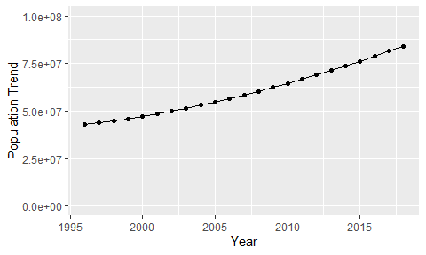

Political Stability Trend

# Population growth trend

The plot shows the population growth rate trend of the country.

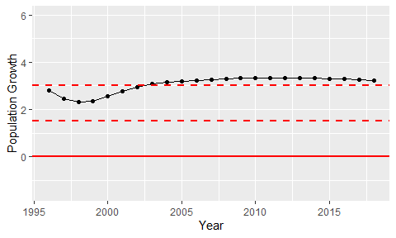

Population Growth Trend